Cover pic

https://www.lovesrilanka.org/sea-turtle-hatchery-and-rescue-centre/

Currently worlds turtle population is around 1.3 million from seven turtles species and out of that 90% is female and only 10% of them are male turtles. Sri Lanka has become home for five species out of these seven.

These turtles nest on many beaches around Sri Lanka

15000 eggs collected each year. then are incubated and the baby turtles are released back into the sea.

* Why turtles should be protected

Protected pic

These clumsy and huge 6foot long reptiles are majorly affected my marine fishing industry because of the waste they left at the sea, these waste accumulate over time and form patches in sea that distracts sea turtles. The sea turtles are then tend to get tangled in these waste that sometimes leads to a tragic ending.

* Turtle hatcheries in Sri Lanka

Currently there are six turtle hatcheries in total around Sri Lanka

* Hikkaduwa , kosgoda and bentota are the main hatcheries among them

and annually 400 sea turtles nest around those areas safely

valuable links

<https://www.kosgodaseaturtle.org/>

<https://amazinglanka.com/wp/turtles-of-of-sri-lanka/>

<https://www.lovesrilanka.org/sea-turtle-hatchery-and-rescue-centre/>

turtle categories

from all around the world there can be seen 7 types of turtles

* + **Green Sea Turtle, Chelonia mydas**

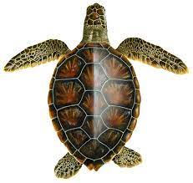

* + **Loggerhead Sea Turtle, Caretta carett**

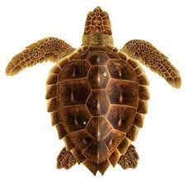

* + **Hawksbill Sea Turtle, Eretmochelys imbricata**

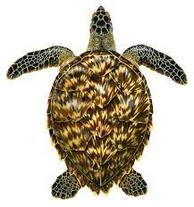

* + **Leatherback Sea Turtle, Dermochelys coriacea**

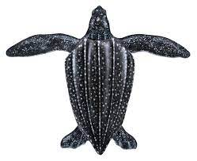

* + **Kemp's Ridley Sea Turtle, Lepidochelys kempii**



* + **Olive Ridley Sea Turtle, Lepidochelys olivacea**

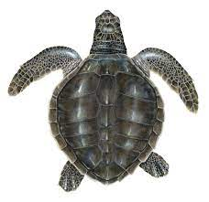

* **Flatback Sea Turtle, Natator depressus**

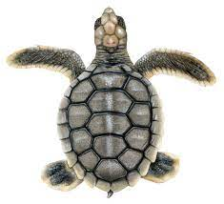

out of this 7 types 5 of them can be seen in Sri Lankan ocean territory

turtle images downloaded from

<https://www.upwell.org>

Beaches where turtles can be seen in Sri Lanka

Since Sri Lanka is an island nation spotting a turtle along the coast line is possible. However the most scenic top spots for turtle spotting and other sports are

* + Mirissa.
  + Trincomalee.
  + Hikkaduwa.

Turtle hatcheries in sri lanka

* Hikkaduwa
* Bentota
* Kosgoda

What a turtle hatchery looks like [Kosgoda Turtle Hatchery.mp4](Kosgoda%20Turtle%20Hatchery.mp4)